# **What’s the Diff? Version History and Revision Reflections**

Chapter Description

This essay recommends that writers use digital tools to keep track of what’s changing as they write – and to include a quick comment with each notable change, saying what they’re trying to achieve. These revisitable histories are helpful in several ways. First, when we notice what we’re changing (often unconsciously) on a small scale, like words and phrases, we can think through our reasons for those changes – and then ask if similar reasoning, and similar revision strategies, might also apply at larger scales of paragraphs and beyond. Second, by sharing and discussing these reasons and strategies, we expand our repertoire of revision moves, moving further along the spectrum from novice to expert. Third, if our writing is interrupted – whether by other classes or by world or life events – re-reading the revision notes can help writers recapture momentum and pick up where we left off. And finally, recording what’s changing helps us see and celebrate small victories, and realize that there is actually progress happening, even when it might not look like it. For example, if each new draft is a scrap-and-start-over of the same three paragraphs until we’ve clarified our goals for the essay, revision histories can show the progress that word counts alone would leave invisible. Without tracking these mid-draft changes, writers’ celebrations can otherwise feel delayed until the project is over, or until a grade comes back – or, worse, never. Noticing and naming progress can generate feelings of interim success to keep ourselves going through difficult stages in the writing process.

## Introduction

Whether you know it or not, you revise as you write. I haven’t met you, but I feel confident saying this anyway. Even if you produce a first draft and never come back to it, something tells me you at least look back at the sentence you’re in the middle of, and sometimes the sentences and paragraphs before that, so you know whether your current thought actually follows on the previous one. Or maybe one of your teachers made a point of telling you to write a rough draft, put the paper away for a while, and come back to it; in that case, you’re probably even more aware of revising. But I’ll also bet that even within each of those sessions, you were in the middle of saying one thing and thought of a better idea, or a better way of saying it – so you erased, you went back to the middle or beginning of the line, and you restructured it. You *saw better*, and so you changed what you were writing. And that’s revision.

In this essay, I want to help you see *revision* better. I want to help you think through what you do with words and sentences, because what we do within sentences we can also do with paragraphs, pages, and even larger chunks of writing. Studies have shown that expert writers revise on those large scales more than beginners do, so learning to think big is part of how we grow our expertise as writers.

And the tool I recommend for seeing revision better is *version history*. You may know it better as *track changes*, or (if you’re into computer programming) *diffs view*, but the basic idea is this: (1) use digital tools to visually mark what’s changed in your writing from one moment to another; (2) add a note that says what that change is meant to accomplish, or where it gets you; (3) reread the notes later on.

## Visually marked changes

Before we can talk about what you’ll learn in studying your own version histories, I want to make sure we’re all on the same page about what I’m describing, and why I find these histories so interesting. Figure 1 shows a simple example of a *diff*, a comparison between two adjacent versions of this document. In this case, I generated it with Google Docs, using the File menu to select See Version History. But there are lots of tools you could use; I’ll have more to say on that later. For now, let’s look at the diff together. You should recognize the context: the sentence is taken from the second paragraph above.

Figure 1. Substitution at the level of words 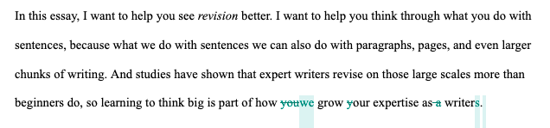

Not earth-shattering, I know; just a slight shift in wording, from *you* to *we*, from *your* to *our*. But a change doesn’t have to be massive to be meaningful. What I meant to accomplish with the change in pronouns was to change my sense of relationship to you as a reader: by including myself in the group that’s growing, I signal that I’m not some expert who’s solved all of writing, come down with wisdom from on high. (If you ever meet that person, send them my way!) I want you to trust me in part because I’m still learning, too – including by writing this essay, and reflecting on my version history. That’s why I’m drawing on examples from this piece, so you can see *how* I’m learning, and what it gets me. True, I’m not exactly a novice, either: I’ve been publishing and teaching writers for almost two decades; I do think about large-scale changes and restructuring. But as this example shows, thinking about the large scales doesn’t mean you stop fiddling with sentences and words as you get more experience.

It might, though, mean you think more about how the small and the large are related, and that’s one of the big things studying your version history can help you do. For example, when I think about my reason for that small change above, *you* to *we*, it raises a question that applies to the essay as a whole: what *is* my relationship with readers? And what follows if I’m not separating myself from the lessons I’m trying to impart? For one thing, my examples might shift from things other people have written about to the things I have found concretely helpful, things that don’t depend on already having a large revision repertoire. It might mean, in fact, spending more time with the word-level edits we all make, and demonstrating how they can themselves lead to high-level rethinking. And so, here we are: all six paragraphs you just read are entirely new additions that weren’t in the first draft.

For the change in Figure 1, the structure of the sentence stayed the same: the main move was one of *substitution* in place, one pronoun for another. But even within a single paragraph, structural changes are possible. Figure 2 shows a diff view from an earlier draft of this essay. I’d written the paragraph in one order, then decided that the last sentence made a better lead sentence – so I reordered them.

Figure 2. Reordering at the level of sentences

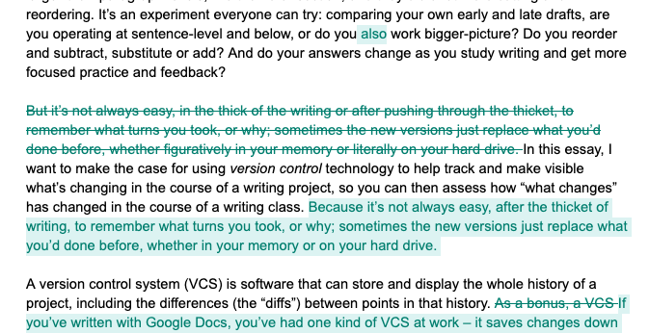

Reordering to highlight main ideas or improve transitions is a strategy worth knowing, if you don’t already. But there’s also another, related, change in Figure 2 that might be obscured by the movement of the full sentence. Do you see it? Between the deleted version (struck through) and the inserted version (highlighted), the first word of the sentence changed. In its original position, the idea that “it’s not always easy” was a contrast with what came before, a turn, and so I wrote it “but”-first; within the paragraph, though, the two ideas go together, so “but” became “because.” Thinking through the reasoning here, we can develop a two-part revision strategy: first, consider whether a position swap makes sense; second, reassess the transitions in light of the new position.

As I said above, the small-scale strategies you can see in these diffs are often worth trying at larger scales. So, knowing that you can reorder sentences within a paragraph, you should start to realize you can reorder whole paragraphs, too. Figure 3 shows the original paragraph from Figure 2, leapfrogging from the position where I’d written it to a position I thought would work better:

Figure 3. Reordering at the level of paragraphs

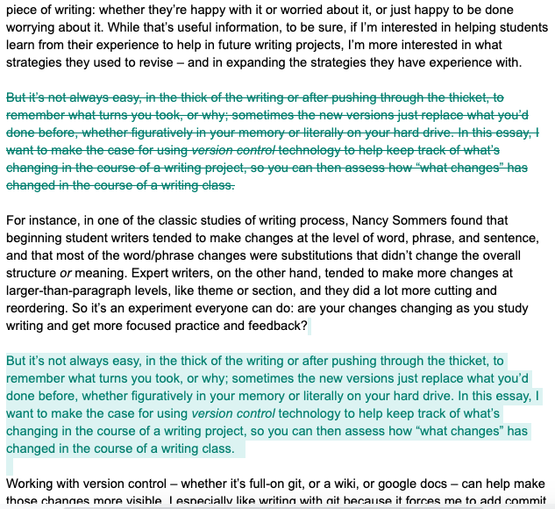

What about that second half of the strategy – re-checking the transitions after the jump? Well, what used to apply to words or phrases (“but,” “because”) here scales up to sentences. As it turns out, checking transitions after reordering the paragraphs was what helped me realize the “but” was no longer working; the sentence reordering shown in Figure 2 was itself a smoothing operation after the paragraph swap. What you learn at one scale, try applying at another: sometimes it works in both directions. (It’s revision strategies all the way down.)

## Noteworthy changes deserve a worthy note

Not every diff is so straightforward as the ones shown above: see Figure 4, which shows a whole tangle of revisions as I worked through how to talk about the changes in my draft up to that point.

Figure 4. A more complicated diff to interpret (so maybe not one for the history books)

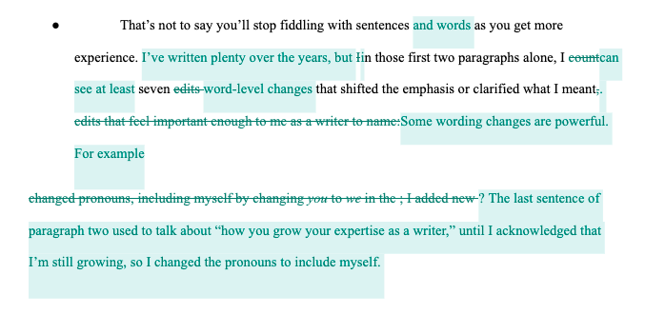

I went from planning a list of seven edits to choosing one to focus on; I tried describing some edits as “important” in a single word, then as a whole expanded phrase, then cut both. This moment in the revision process was kind of a mess, really. Why show it to you, then? A few reasons.

First, to make sure I’m not overstating my claim or setting you up for confusion. The truth is, not *every* diff is important or a source of great insight. Sometimes, the best response is to acknowledge that drafting is messy, and move on. Second, following from that truth, the moments that *do* feel like accomplishments are worth marking, so you can find them again later. (See Figure 5, where several revisions are marked with notes, and the less interesting moments in the history are marked simply as dates.)

Luckily, many writing tools with version trackers (including Google Docs[1] as of this writing) let you add “named versions”[2] within the file’s history. You can use these names to say where you are relative to some point in the process, as in “first draft” or “500 words to go”; or, even better, you can use the notes to briefly describe what’s changing, and why. A note like “first draft” doesn’t tell you, if you look back at it later, how far you’d gotten by the first draft. By contrast, a note like “reorder Ophelia quote from third page to first” or “finished section on barracudas” tells you what you’ve actually done. A glance back through a series of such notes when the essay is complete can help you call to mind all the highlights of your process and reflect on what you learned – or what you want to ask for feedback on.

Figure 5. Annotated revision history (“named versions”). 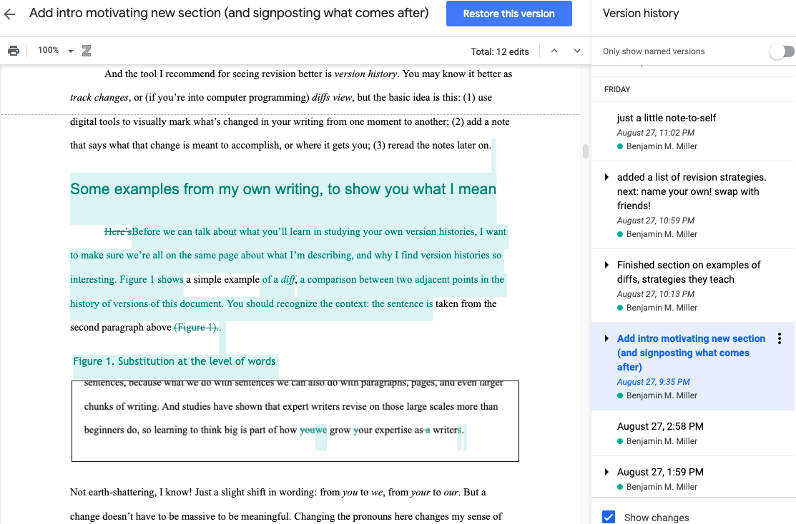

But even before the essay is complete, these notes can be powerful. Pausing to describe what you were just working on – even pausing to decide *whether* to describe what you were working on – opens up a space for reflection. Version notes invite you to think actively about how you’re writing, whether to save a move you just made for future reference or to compare your present writing situation to others you’ve been in before. And that kind of metacognition, or thinking about your thinking, has been found to be important in developing expertise (*How People Learn* 50, 18).

What’s more, if your writing is interrupted (life happens), version notes can be a place to lay down tracks for yourself to return to. Scrolling through just the noteworthy moments when you get back, you might well recover the momentum you had when you left off, allowing you to resume midstream rather than just read the whole draft from the top. Paul Ford, writing in the *New York Times magazine* about open source software, had a memorable take on this kind of process recap. In his words, “I read the change logs, and I think: humans can do things.” If you find yourself in the grip of writer’s block, version notes can offer a reminder: you, a writer, can do things.

## Looking back to look forward

I’m taking the phrase “revision strategies” from one of the classic studies of writing processes, by Nancy Sommers. By comparing early and late drafts in two groups of writers, she identified four recurring “operations” – addition, subtraction, substitution, and reordering – taking place at four different “levels” of text: word, phrase, sentence, and “theme (the extended statement of one idea)” (Sommers 380). Most interestingly for practical purposes, she found a difference between the two groups based on their experience level. Beginning student writers tended to make changes on the scale of words, phrases, and sentences, and most of the word/phrase changes were substitutions: they didn’t change the overall structure or even meaning, since a lot of the substituted words were synonyms. Professional adult writers made small changes, too, but also tended to go beyond—they made more changes at larger-than-paragraph levels, like theme or section, and they did a lot more cutting and reordering.

Their revision *goals* were different, too: the student writers in Sommers’s study mostly wanted to “clean up” their early drafts (381), while the experienced writers talked about taking their drafts apart to find the heart of the argument (383-4) – in a sense, using revision to “rough up” the earlier draft and make something better from the pieces. Sommers’s experiment was a long time ago, but it’s an experiment you can repeat even more easily now, with your own writing: When you have to revisit a first draft, do you look for ways to “clean it up”? Or do you ask yourself what else, what next idea or better explanation, the draft helps you figure out?

What do you think your revision history would have to say about it?

It’s worth asking, because what we think we’re doing and what the evidence shows aren’t always the same. In 2018, Heather Lindenman and colleagues published a study comparing students’ drafts with reflective memos they’d written about them. They found that many students claimed to have learned new revision skills in their first-year writing courses, but those revision moves weren’t actually there when the researchers looked at the diffs. As the authors put it, “students articulated improved writing knowledge in their memos—they talked the talk—but they did not enact it in their revisions—they did not walk the walk” (589). So if you feel like you’ve realized something new this semester about how to improve your writing, it’s worth checking to see if it’s actually showing up in your latest drafts. What you expect is changing in your writing, or what you hope is changing, may or may not be visible there.

It’s not always easy, in the thick of the writing or after pushing through the thicket, to remember what turns you took, or why; sometimes the new versions just replace what you’d done before, whether figuratively in your memory or literally on your hard drive. Using version history can help you keep track of what you’ve done throughout the course of a writing project, so you can then assess how your strategies have changed—and where they might be useful again in the future.

So before you write a final reflection, on either that piece of writing or a whole course, you’d do well to grab some evidence from your revision history. Or, if you find it’s not there yet, you can start making some new history now.

## The more strategies, the merrier

To find more revision strategies, you may only have to start looking at drafts where something really clicked – where you know your revisions really improved the final product. But to get the most out of it, work with a group. If you share what you find among peers, classmates, or other writing partners, the chances increase that everyone will pick up something new.

In the interest of such sharing, here are a few moves I’ve noticed recurring in my diffs:

* *Thickening.* Add a new sentence between two existing ones, putting flesh on the bones of an idea. Especially useful around quotations that need more context.
* *Prying open.* The scaled-up, paragraph-level version of thickening: add a whole new paragraph between existing paragraphs, e.g. to insert a more concrete example of an abstract idea, or to acknowledge and respond to some possible misreading. Also works with sections (see Figure 7).
* *Regrouping*. Sometimes, instead of new material, all you need is a change in punctuation. Adding a period (or a paragraph break) can sometimes let your readers catch their breath and fully understand one thought before you ask them to move on (see Figure 6). Section headings can do the same at a larger scale (see Figure 7). Conversely, substituting a semicolon for a period can emphasize how closely two ideas are related.
* *Reframing*. Add new material at the beginning of the draft (or paragraph, or section) with the goal of helping readers see how the existing material fits into a larger conversation. See Figure 8, below, for an example. Note that this could also be considered a scaled-up version of a traditional sentence-level strategy like *adding transitions*.
* *Removing the scaffolding*. Kind of the opposite of reframing: delete preparatory passages that aren’t part of the actual building / idea, even though you couldn’t have built it without them.
* *Making it explicit.* Add new material at the end of a sentence, paragraph, or section to explain the significance or consequence of what you just said. Say outright what you thought was implied the first time.
* *Fine-tuning*. Substitute individual words to adjust their overtones, so they better match your intended root meaning. (For example, I wanted “overtones” in that sentence rather than “associations,” because “overtones” is associated with music and reinforces the musical aspect of “tuning.”)

To find these, as I said, I went through my version history and tried to (a) describe the changes I saw, and (b) explain what I hoped each change would accomplish. You can do the same, especially if you already took notes as you went along to mark the revisions of which you’re the most proud.

Figure 6. Regrouping at the sentence level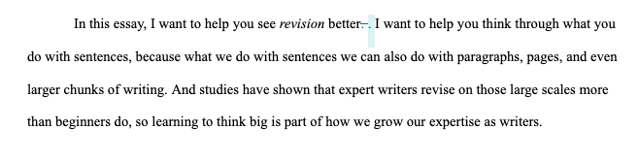

Figure 7. Regrouping to carve out an extra section within an existing one

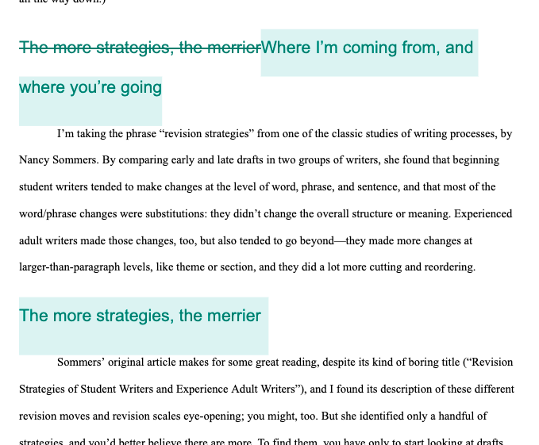

## From discovery to planning

So far, my advice has mostly been retrospective: I’m asking you to look back at the revisions you’ve already made, and glean strategies from them. That’s not a bad place to start, but the bigger goal isn’t simply to label and catalog all these moves, but rather to use them moving forward, to improve your writing by expanding the ways you know how toimprove your writing. This raises an important question: How will you know when to apply one kind of strategy over another – when to add more in the middle or the beginning, when to reorder or regroup?

Figure 8. Reframing by adding at the start of a section

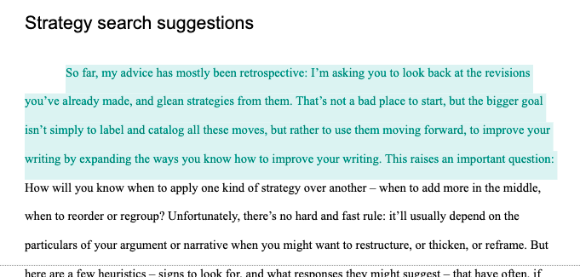

Unfortunately, there’s no hard and fast set of rules: it’ll ultimately depend on the particulars of your argument or narrative when you might want to restructure, or thicken, or reframe. Sometimes the best approach is to ask friendly readers where they have questions, or had to reread multiple times before they understood. But here are a few heuristics – signs to look for, and what moves they might suggest you try – that have often, if not always, prompted a revision. And above all, just knowing *to* look is itself an important first step.

* *Distant callbacks may be a sign reordering is possible.* If you find yourself saying things like “As I said earlier,” it’s worth checking how muchearlier it was. If readers have to remember your point from before a whole intervening section, maybe it would make more sense to reposition the new part closer to the first part. On the other hand, maybe all you need is a *regrouping*: could you add new section titles to help readers anticipate the jump away and back? That might make it easier to follow your line of thought.
* *To think about the large-scale structure, try bringing it down to size,* e.g. with a reverse sentence outline*.* A reverse outline is one you write after a draft exists, allowing you – like Sommers’ experienced adult writers – to search that draft for the shape of an emerging argument, rather than assume the argument is already clear. By outlining in sentences, you essentially scale down the big picture into a paragraph or two: for many writers, a more familiar and manageable space in which to regroup, reorder, and recognize gaps to fill in (or extraneous chunks to cut). Once you’ve done it with the outline, the corresponding changes you can make in the piece as a whole should be easier to identify.

There are troves of authors with advice and suggestions of moves to try; I’ve found Wendy Bishop’s “Revising Out and Revising In” and E. Shelley Reid’s *Solving Writing Problems* to be particularly helpful. Whatever move you choose, if you take a note as you’re trying it, you’ll be able to come back later and assess how successful it was for your draft. And seeing it in the context of your other named versions will help you consider whether it might work as well, or better, at another point in your process or on another level of scale.

## A parade of small rewards

Looking back and looking forward are all well and good, but for my money it’s the mid-process reflection that keeps me coming back to diffs. Recording what’s changing helps us realize that there *is* actually progress happening, even when it might not look like it. As someone who has struggled with writer’s block and anxiety for as long as I can remember, many of my first drafts don’t look like much of anything, often for a long time. But a look through my diffs shows the progress that word counts alone would leave invisible: the hundreds of words written, then erased; the paragraphs of ideas in a particular order that turned out to be incompatible with another structure, and so had to be cut. In naming that revision, even if the revision move is subtraction, we get to pause and celebrate the writing that was there.

When do you usually celebrate your writing? When the essay is complete? When a grade comes back (depending on the grade)? When you don’t have to think about it any more? By acknowledging the hard work and successes of mid-draft changes, version history reminds us that the journey itself is studded with small victories.

## **Works Cited**

Bishop, Wendy. “Revising Out and Revising In.” *Acts of Revision: A Guide for Writers*, Boynton/Cook Heinemann, 2004, pp. 13–27.

Ford, Paul. “Letter of Recommendation: Bug Fixes.” *The New York Times*, 11 June 2019. *NYTimes.com*,<https://www.nytimes.com/2019/06/11/magazine/letter-of-recommendation-bug-fixes-git.html>.

*How People Learn: Brain, Mind, Experience, and School: Expanded Edition*. 2nd ed., National Academy Press, 2000. <https://www.nap.edu/catalog/9853/how-people-learn-brain-mind-experience-and-school-expanded-edition>.

Lindenman, Heather, Martin Camper, Lindsay Dunne Jacoby, and Jessica Enoch. “Revision and Reflection: A Study of (Dis)Connections between Writing Knowledge and Writing Practice.” *College Composition and Communication*, vol. 69, no. 4, June 2018, pp. 581–611.

“Named Versions: What You’ll Love about the New Version History for Google Docs.” Google Apps Script Examples. https://sites.google.com/site/scriptsexamples/home/announcements/named-versions-new-version-history-google-docs. Accessed 4 Sept. 2020.

Sommers, Nancy. “Revision Strategies of Student Writers and Experienced Adult Writers.” *College Composition and Communication*, vol. 31, no. 4, Dec. 1980, pp. 378–88.

Teacher Resources

*Overview and Teaching Strategies*

This essay is intended to support students in making conscious interventions in existing drafts, starting by exposing the specific textual changes from one draft to another. For purposes of reflecting on past and current practices, the chapter may work best if read after students have already begun revising their compositions, as not everyone will have saved work from previous courses. On the other hand, it also encourages students to develop a writerly practice of recording revision intentions with each diff they recognize as significant enough to put a label on. Doing so effectively takes, well, practice, and so I would recommend starting relatively early.

I have found that some feedback on version notes – see Supporting Exercise 2, below – can help students learn to write them in a way that still makes sense when read weeks later. Even stating that future-self as an audience, and reminding students of the goal of writing for that audience, seems to help over time. Early on, it can be helpful to model the process in real time (e.g. while revising something together in class), or in a screencast.

Several pieces of comp/rhet scholarship inspired the ideas in this essay, and could be similarly inspiring for students to read (or read excerpts from) alongside it. Nancy Sommers’ “Revision Strategies of Student Writers and Experienced Adult Writers” would be a natural companion, as I lean on Sommers’ analysis, but present only one finding from her complex article. Lindenman et al’s “Revision and Reflection: A Study of (Dis)Connections between Writing Knowledge and Writing Practice,” which in some ways prompted this piece’s deep dive into diffs for a student audience, could also work well for a Writing About Writing course. Finally, the Wendy Bishop chapter I mention, “Revising Out and Revising In,” from her collection *Acts of Revision*, is written with an undergraduate audience in mind, offers over 70 suggestions for revision moves, with fun names. I have often asked my students to pick three of Bishop’s exercises, try them in their current drafts, and then discuss in the next class or their final reflections what happened: Would they try it again? At the same or a different point in the process? Why?

*Questions after a first reading*

1. Which of the revision “moves” described in the essay have you tried in your own writing, and which might you want to try? Are there any you’re familiar with, but you think of through different names? How might the names you choose help you think through the move at different scales (word, sentence, paragraph, section, etc)?
2. This essay sometimes treats revision through a mathematical metaphor: addition, subtraction, substitution, reordering, and regrouping are all things we can do in algebra as well as writing. Are there any other operations or relationships from math that might be relevant to how you think about writing and revision? e.g. What would a distributive property look like in a sentence, or an essay? Are there times you might want to multiply, or to divide?
3. The figures in this essay include a variety of “revision notes.” Which messages tell you the most about the goals or the content of the revision? Which tell you the least?

*Supporting Activities*

1. Look at your own diffs between drafts of a recent project. What revision operations (addition, subtraction, substitution, reordering, regrouping) can you see, at what scales (word/phrase, clause, sentence, paragraph, section)? Try to remember what your goals were in making those changes. Do your revision history and your goals match those of the students or experienced writers in Sommers’ study, at least as Miller has summarized them here?

2. Trade revision histories with a partner, and read through the top-line commit messages / version names. Can you tell what your partner was changing? At what scale (word/phrase, clause, sentence, paragraph, section) would you expect to see those changes? Make a note of particularly clear messages, where you get a sense not only of what changed, but why: i.e. what the goal of that revision was for your partner. Also make a note of any vague messages, i.e. messages telling you only that *something* changed, but not what. Share these new notes with your partner, and see if you can together rewrite any vague messages to be more like the clear ones.

3. To increase your experience with large-scale structural revision (reordering and regrouping at the paragraph level and above), try a *reverse sentence outline* on index cards*.* The key difference between this and a more traditional outline is that, rather than listing broad topics (eg. "senior year of high school") or inert evidence (eg. "questions on AP exams"), you're listing thoughts, claims, and questions (eg. "AP exam questions were open-ended, requiring me to decide on my own what information was relevant"). The “reverse” part means that you’re outlining a draft that already exists, rather than projecting into the future of a draft you have yet to write.

To make a sentence outline, follow these steps: (1) Number the paragraphs in your draft. (2) Read through your draft, looking for your key points – moments where the thinking moves or the essay turns. Each time you find one, write it onto its own index card as a *single full sentence*. Leave out transitions (e.g. "for example"). If you find you need to compose a new sentence to capture the thought, do so. If a point takes two sentences, use two cards. (Instead of using index cards, you could copy all these sentences onto a single sheet of paper. This has the advantage of keeping everything together, making it easier to see the shape of your essay. But it also has the disadvantage of keeping everything together, making it harder to *re-*see the shape of your essay.) (3) As you go, on the *back* of each card, write the number of the paragraph that this idea appeared in. You may have one of these key ideas per paragraph, or two, or three, or none. This in itself is useful information to have; it will help you regroup or consolidate or expand.

Congratulations! With these cards in order, you’ve produced a basic sentence outline of the thinking moves and turning points in your essay. But noticing the structure as it exists is only one step in re-seeing; to see it as it *might* exist, continue with the next several steps. (4) On the back of each card, write a letter that will help you recover this original order: that is, label the first card A, the second card B, the third C, etc. If you have more than 26 cards, continue with A', B', etc. This is important because of the next step, which is to (5) shuffle the cards, then flip them back to the front (where the sentences are). Rearrange them in such a way as to make a logical paragraph, or short set of paragraphs. If you need to add any new sentences to fill in gaps, do so one new cards, still with one card per sentence and one sentence per card. If some cards don’t fit into your new paragraph, or merely duplicate other cards, you can leave them out. (6) When you are done, write down the new sequence of letters in your notebook, so you can recover this revised order. (7) Compare the results of steps 4 and 6. Based on any reorderings, additions, or subtractions you’ve made to the sentence outline, what reorderings, additions, or subtractions does that suggest for the essay as a whole? Based on your information from step 3, are there any paragraphs you’d like to combine and consolidate? Are there any paragraph breaks you might now add, to highlight your thinking moves?

1. I learned only in the course of preparing this essay that Google Docs limits the number of named versions: in 2021, to 40 changes. Beyond that, you’d have to un-name a previous save or start in a new document.
2. One version tracker popular among programmers, called git, only saves these named versions, which it calls “commits.” I kind of love the energy of that: it’s like, “Okay, I know you’ve saved this file, but are you ready to commit to it? Is this an official version you’d want to look at again later?”